**Tracking Soil Nitrogen Loss and Availability**

**Report for Year 3 (2017), Project 802 NREC 2015-02615, March 2018**

Emerson Nafziger and Cameron Pittelkow, Crop Sciences, Junming Wang, Illinois State Water Survey, and Dan Schaefer, IFCA

This project was initiated to use soil N data gathered under the N-Watch program and to generate new data on soil N trends following application of different forms and times of N application in small-plot trials at research centers and on farmer fields.

**N-Tracking Procedures in 2017**

N-tracking studies at the four central-northern Illinois Crop Sciences Research & Education Centers were carried out as planned, with the following treatments: 1) 200 lb. N per acre as NH3 in the fall; 2) 200 lb. N per acre as NH3 without N-Serve; 3) 200 lb. N per acre as NH3 in the early spring (2 to 3 weeks before planting) without N-Serve; 4) 200 lb. N per acre as NH3 in the early spring with N-Serve; 5) 100 lb. N as NH3 in the fall with N-Serve + 50 lb. N as UAN at planting + 50 lb. N as UAN at sidedress (V5-V6); 6) 50 lb. N as UAN at planting + 150 lb. N as UAN at V5-V6 sidedress; 7) 100 lb. N as NH3 in the fall with N-Serve to provide a lower N rate (added in 2017); 8) A check without N fertilizer. These same treatments were applied as part of on-farm N rate trials at three sites, one each in McLean, Ford, and Christian Counties.

We also established a trial with a range of N treatments near Neoga, in Cumberland County, and sampled soil to track N in four treatments: zero N; 150 lb. N/acre as UAN at planting; and 50 lb. N at planting followed by 100 lb. N as UAN at V5-6 or at V9 (6/28/17).

The following table provides dates for N applications and planting in 2017.

|  |  |  |  |  |
| --- | --- | --- | --- | --- |
|  | NH3 application | | Planting | Sidedress |
| Site | Fall | Spring | date | date (V5-6) |
| DeKalb | 11/16/16 | 4/24/17 | 5/18/17 | 6/19/17 |
| Monmouth | 11/15/16 | 4/18/17 | 4/25/17 | 6/6/17 |
| Urbana | 11/14/16 | 4/17/17 | 4/19/17 | 6/5/17 |
| Perry | 11/15/16 | 4/17/17 | 4/24/17 | 6/6/17 |
| Neoga | none | none | 5/17/17 | 6/14/17 |

Soil samples were taken from two reps of each N treatment beginning in fall after application, at the time of or following early spring application of NH3, at planting, and then every 14 days after planting up to tasseling. Samples taken at 0 to 1 and 1 to 2 ft. depths, and were sent to a commercial soil lab for analysis of NO3 and NH4. Soil N amounts were calculated as lb. N/acre in the top 2 ft., by multiplying average ppm values by 8. Yields were taken by plot combines on the RECs and at the Neoga site, and by hand-harvest at the on-farm sites due to these treatments being added into the end of on-farm, field-scale N trials. We also took soil samples after harvest in the on-REC sites to see how much N remained following fall NH3 + N-Serve, spring NH3 without N-Serve, 50 lb. N at planting followed by 150 lb. N at sidedress, and the zero-N check.

**Results**

As shown in Table 1 below, April rainfall was above-normal at all of the REC sites in 2017; most of this fell during the last week of the month. The first part of May was also wet in some locations (especially at Urbana and Perry), then the first half of June was dry. Rain fell during the second half of June at all sites, but monthly rainfall less than normal. July rainfall ranged from only about half of normal at Urbana (2.2 inches) to normal at Monmouth to well above normal (6.8 inches) at DeKalb. At Neoga, our cooperator provided rainfall data showing totals of 5.8 inches in May and 2.1 inches in June. Even with below-normal rainfall during the rest of grainfill, Illinois corn yields were high to very high in 2017.

Table 1. Monthly rainfall at the four Research & Educations Centers in 2017.

|  |  |  |  |  |
| --- | --- | --- | --- | --- |
|  | DeKalb | Monmouth | Urbana | Perry |
|  | --------------------inches------------------- | | | |
| April | 6.2 | 6.3 | 6.2 | 7.6 |
| May | 4.0 | 2.9 | 5.6 | 6.5 |
| June | 2.7 | 2.5 | 2.6 | 3.7 |

Soil N: In general, N uptake patterns in 2017 were similar to those in 2016; the large amounts of rain that fell after spring N application appeared to have little effect on soil N levels during May. At DeKalb, where planting was delayed until after the April-May rainfall, soil N levels remained fairly constant through May, and then, as the crop took up N during June, declined somewhat more gradually than we found in 2016. By the end of June 2018, soil N levels in the top 2 ft. of soil were still in the range of 130 to 230 lb. N per acre (Figure 1) compared to levels of about 160 lb. N in 2016. From late June to tasseling, soil N declined more in the fall-spring split N treatment than in the other treatments; by tasseling, this treatment had barely more N than the treatment with no N fertilizer, while other treatments still had more than 100 lb. N. which we would consider adequate for full yields. At Monmouth, amounts of soil N recovered rose through May, to about 250 lb. N/acre in the ammonia treatments, with less in the sidedress treatments, which only received their last N in early June (Figure 2). Soil N levels declined from early to mid-June, and then remained mostly flat, with only 100 to 150 lb. N/acre from mid-June through tasseling. These levels did not differ much by N form and timing, and they were somewhat lower than we saw at this site in 2016.

Soil N levels at Urbana in 2017 (Figure 3) showed a pattern similar to what we found in 2016, but levels were somewhat higher than normal for most treatments during June (possibly due to dry weather), and the decline from early June through tasseling was not as steep as we saw in 2016. The treatments with fall-applied ammonia dropped to about 100 lb. soil N/acre by late June and remained there, while spring-applied ammonia and the spring-split (50 lb. at planting and 150 lb. sidedressed) had 100 to 150 lb. soil N remaining at tasseling. At Perry, soil N declined in a more typical manner, with the ammonia treatments all declining from 150 to 200 lb. N in early June to only about 50 lb. N by tassel, while those treatments that received sidedressed N showed higher levels at tasseling (Figure 4). At Neoga, soil N levels reflected timing of application, but all treatments (with 150 lb. N/acre) had at least 100 lb. N in the soil at tasseling, which should have been adequate for yield (Figure 5).

Soil N levels following crop harvest were less than 50 lb. N/acre regardless of N treatment at DeKalb and Monmouth in 2017, while at Urbana, spring-applied ammonia, and at Perry, the spring-split (50 at planting + 150 sidedressed) treatments had more than 100 lb. N in the top 2 feet of soil after harvest (Figure 6). While the higher levels at Urbana and Perry likely reflect the drier conditions there during August and September, the amounts of post-harvest soil N were generally low in 2017.

The treatments with fall-applied N and without fertilizer N were sampled at the on-farm sites beginning in the fall, and continuing through the winter when conditions allowed. February 2017 was a particularly warm month. As we have often observed, soil N levels appear to rise for several months following application (Figure 7). We have no good explanation for this phenomenon, but have stopped taking samples right after application in most cases, knowing that samples taken then will not show the actual amount of N applied. After planting (which took place April 15-20 at the three sites), soil N levels trended down slightly in May before dropping in June; by tasseling levels averaged only about 100 lb. N/acre among the treatments (Figure 8). For unknown reasons, spring ammonia without N Serve showed higher soil N levels during May than did spring ammonia with N-Serve. In the samples taken in June and July, the spring-split (50 at planting + 150 sidedressed) had the highest amount of soil N, as expected given the late application. Soil N levels following fall-applied N were low in the June and July samples.

Using the data from the Urbana REC as an example, we again noted that fall-applied N was mostly nitrate by April, whether or not it included N-Serve (Figure 9). Using N-Serve with spring-applied ammonia appeared to slow the conversion to nitrate, at least at the mid-May sampling – the “bounce” with sampling may have resulted partly from sampling error. Of the ways to apply N in this project, though, the most effective way to slow the conversion of ammonium to nitrate is to apply ammonia in the spring. Applying UAN as sidedress can temporarily lower the amount of N recovered as nitrate as well, but this effect doesn’t last very long in the warmer soils following sidedress applications (Figure 9).

Yield: Corn yield was higher with 200 lb. N per acre than without N at all REC sites in 2017, but differences among the treatments receiving 200 lb. N were not very consistent among the REC trials (Table 1). At DeKalb, the spring-split treatment was the highest-yielding treatment although it yielded statistically more than only fall ammonia with N-Serve. This difference does not match up with soil N content; although fall ammonia with N-Serve had relatively low soil N by tasseling, it was still higher than with the fall-spring-split treatment, which yielded 11 bushels more. In contrast, at the Monmouth site, the spring-split treatment yielded statistically less than the other treatments that supplied 200 lb. of N (Table 1). This is not the first time this has happened; even though we often see soil N higher in vegetative stages where 150 lb. of the N has been applied as sidedress, this treatment sometimes yields less than treatments in which all of the N is applied early, including as early as in the fall before. In fact, the spring-split treatment at Urbana yielded less than the other treatment providing 200 lb. of N, although only one of those treatments (spring ammonia with N-Serve) yielded statistically more than the spring-split treatment. At Perry, where dry conditions limited yield, none of the 200-lb. N treatments yielded more or less than the others (Table 1). As we have seen rather consistently in this work, yield differences cannot be predicted by differences in the amount of soil N recovered at various times during vegetative development.

Yield response to N form and timing in the on-farm N-tracking sites were, with some exceptions, consistent with the responses found at the research centers. At the Ford County site, using N-Serve with either fall- or spring-applied ammonia increased yield, but especially with the spring application (Table 2). There were no statistical differences among N treatments (at the 200-lb. rate) at the McLean County site, but at the Christian County site, the spring-split treatment yielded less than fall ammonia with N-Serve or spring ammonia with or without N-Serve (Table 2). Analyzed across the on-farm sites in 2017, the highest yields were from fall or spring ammonia with N-Serve, and the lowest from fall ammonia without N-Serve and from the fall-planting-sidedress split.

At the Neoga site, yields with 150 lb. N applied at planting, and with 100 lb. N at planting followed by 50 lb. N sidedressed at V5 or at V9 were, respectively, 169, 179, and 150 bushels per acre; the only statistical difference was the higher yield from sidedressing at V5 compared to sidedressing at V9. It’s likely that with dry weather at this site, applying some of the N as late as V9 limited its availability to the crop.

In 2017 we again sampled corn plants in the zero-N, 200 lb. spring NH3, and 100 fall + 50 at planting + 50 at sidedress treatments. The amount of N in the plants following 200 lb. of spring-applied ammonia without N-Serve was fairly consistent among the REC sites in 2017, with the exception of Perry, where sampling was on a slightly different schedule (Figure 10). At the other three sites, plants took up about 100 to 110 lb. N per acre by stage V8-9 and about 120 lb. N per acre by VT; the amount taken up by VT was a little greater – 136 lb. N – at Perry. If we assume that plants take up a total of about 1 lb. of N per bushel of grain yield, the amounts at VT (which is very close to, or the same as, stage R1) were much lower than we would normally expect: at DeKalb, Monmouth, and Urbana, only 49, 44, and 51%, respectively, of the total N requirement was taken up by VT. With yields at Perry limited by dryness, this value there was 80%. In 2016, plant N content at VT represented 96, 50, 106, and 75% of total N requirement at DeKalb, Monmouth, Urbana, and Perry, respectively. We have no reasonable explanation why this would have been so different over the two years, but the fact that it was casts doubt on the value of plant N at a certain stage as a predictor of grain yield. Plant growth and N uptake rates are clearly highly variable among different environments.

**Summary**

Even though weather conditions in 2017 were much different than in the two previous years, soil N trends were overall quite similar to those in 2015 and 2016. We again found in 2017 that soil N content during vegetative growth is poorly correlated with plant growth and yield potential; as long as adequate fertilizer N is applied, the crop is not likely to run out as a consequence of having applied N at the wrong time or in the wrong form. We found that using N-Serve increased yields, but these were not consistently related to finding more soil N where nitrapyrin had been used.

Of particular value in 2017 was our finding that 4 to 7 inches of rain between the time of spring N application and crop emergence caused little “loss” of soil N, and that crops yields did not reflect differences in soil N caused application at different times. We again found that keeping most (150 of a total of 200 lb.) of the N to apply at sidedress did not tend to increase yield, and in some cases lowered yield compared to applying all of the N early (spring or even fall). This supports our developing hypothesis that inadequate N during early crop growth might limit yield potential and lower yields, even when adequate N is applied later.

**N modeling (Dr. Pittelkow) and App development (Dr. Wang)**

Activity on these two portions of the project continued in 2017. These reports are attached to the end of this section: one is taken from a modeling manuscript by Dr. Pittelkow and his post-doc, and the other is a description of the app that Dr. Wang has been developing. Both use data being generated in the N-tracking project reported here.

**Outreach**

Results of this work were made known through the Extension presentations, including the IFCA Conference in January 2018, and webinars in March 2017, October 2017, January 2018, and February 2018. Seven UI Bulletin articles addressing N management were published in 2017: February, April, May, June (2), September, and October. Of particular interest in May and June was the effect of early-season rainfall on N status and N nutrition; these were based heavily on data generated in this project. I spoke at meetings using results from this research project in Ontario (Canada), Livingston County, IL; Ada, OH; Belleville, IL; Baton Rouge, LA (NUE conference), Champaign, IL (Agronomy Day); Tampa, FL (ASA meeting); Springfield, IL (AgMasters, 2 presentations); and Indianapolis, IN (IN CCA conference.) Credit was given to NREC for funding in each presentation. Audience totals for in-person presentations over the past year is estimated at 1,500.

**Budget**

The budgeted amounts were spent as planned in FY 2017; following is the record of expenditure (from the beginning of the project on January 1, 2015 through March 31, 2018.) Remaining funds under the control of Drs. Pittelkow and Wang are mostly for personnel, and will be spent to finish up their portions of the project. Remaining travel and services funds will be spent to travel to trial sites and to analyze soil samples taken under this project. This was a 3-year project originally scheduled to end on February 28, 2018; it was extended for one more year, to cover through the 2018 season, ending on February 28, 2019.

|  |  |  |  |  |
| --- | --- | --- | --- | --- |
| **Line Description** | **Budget** | **Expenditures** | **Encumbrances** | **Balance** |
| Total Salaries and Wages | 320,099 | 248,380 | 25,305 | 46,413 |
| Total Fringe Benefits | 135,128 | 78,296 | 6,741 | 50,091 |
| Total Travel | 11,400 | 5,420 | 0 | 5,980 |
| Materials and Supplies | 1,000 | 620 | 0 | 380 |
| Publications and Printing | 0 | 78 | 0 | -78 |
| Services | 51,300 | 36,654 | 0 | 14,646 |
| Miscellaneous | 676 | 0 | 0 | 676 |
| Total Other Direct Costs | 52,976 | 37,352 | 0 | 15,624 |
| Total Indirect Costs | 57,657 | 41,020 | 3,560 | 13,077 |
| Project Totals | 577,260 | 410,468 | 35,607 | 131,185 |

**Plans for 2018**

We plan to use the same set of treatments used in 2018, and to again run the same types of trials. The trial at DeKalb was moved for 2018 to a farmer field nearby the REC. The smaller trial being conducted in southern Illinois (these started originally as part of Dr. Rachel Cook’s project and I didn’t report on them here) will continue at the Neoga site, where we have had trials since Brownstown closed after the 2015 season. This is on a Cisne soil, but a more productive one than we had at Brownstown. Dan Schaefer established the on-farm tracking trials in the fall of 2017; that will be done at three sites in 2018, the same as in 2017.

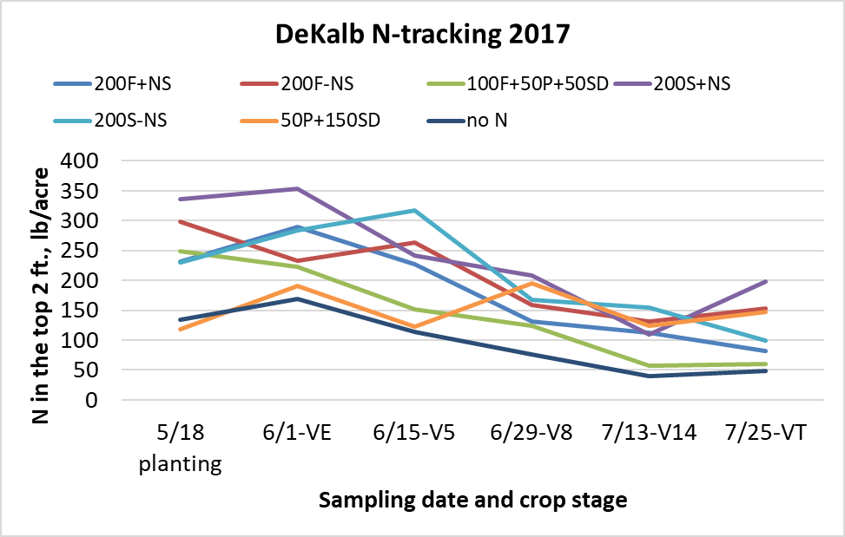

Figure 1. Soil N following application of N at different times and forms, DeKalb, 2017.

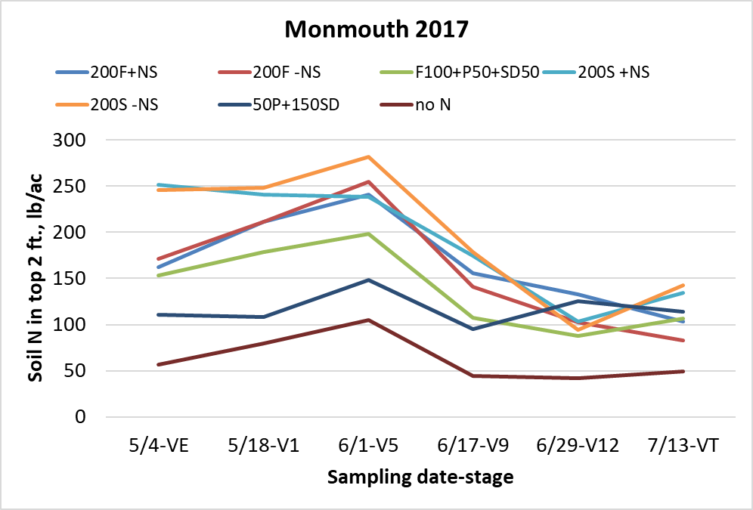

Figure 2. Soil N following application of N at different times and forms, Monmouth, 2017.

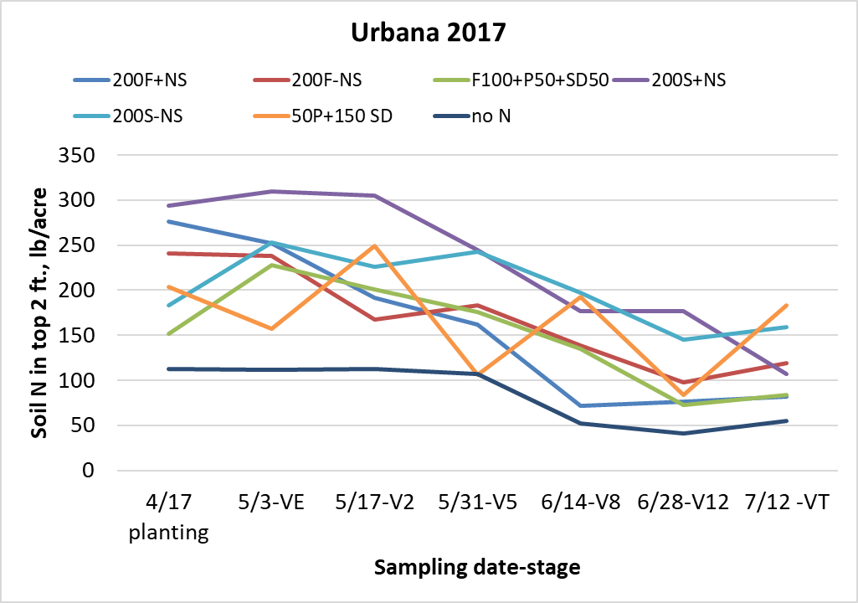

Figure 3. Soil N following application of N at different times and forms, Urbana, 2017.

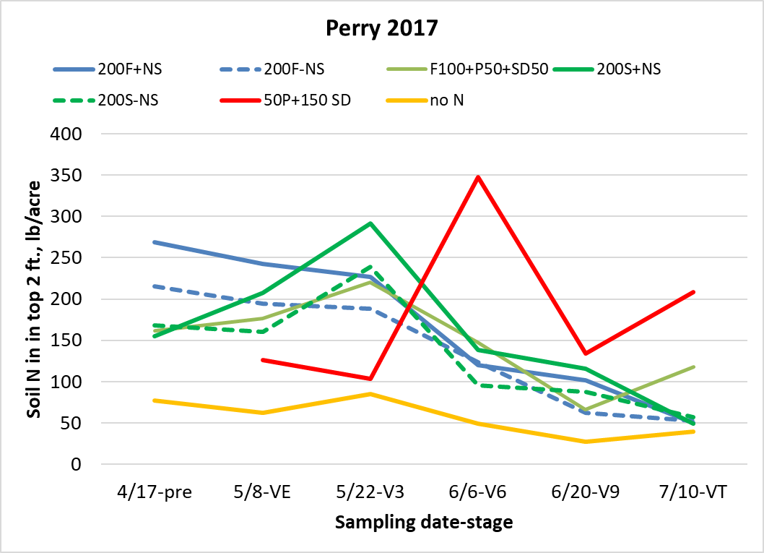

Figure 4. Soil N following application of N at different times and forms, Perry, 2017.

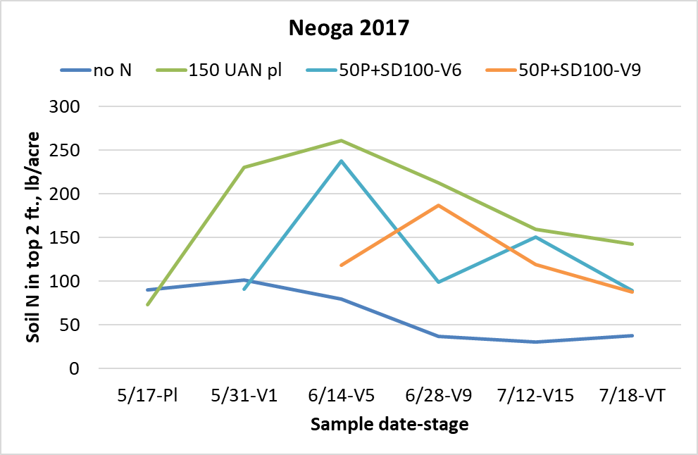

Figure 5. Soil N following application of N at different times and forms, Neoga, 2017.

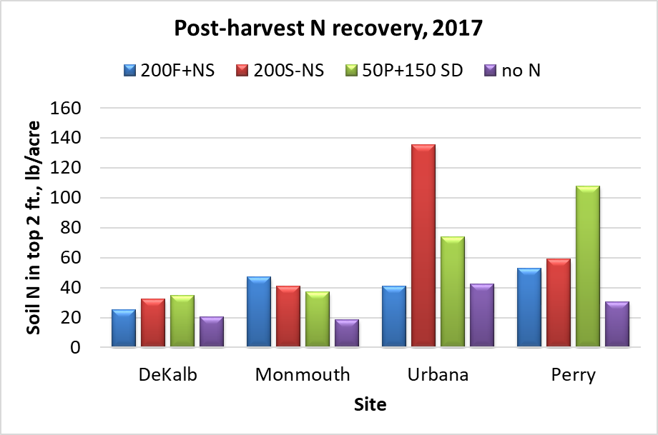

Figure 6. Soil N following application of N at different times and forms at the four research center sites in 2017.

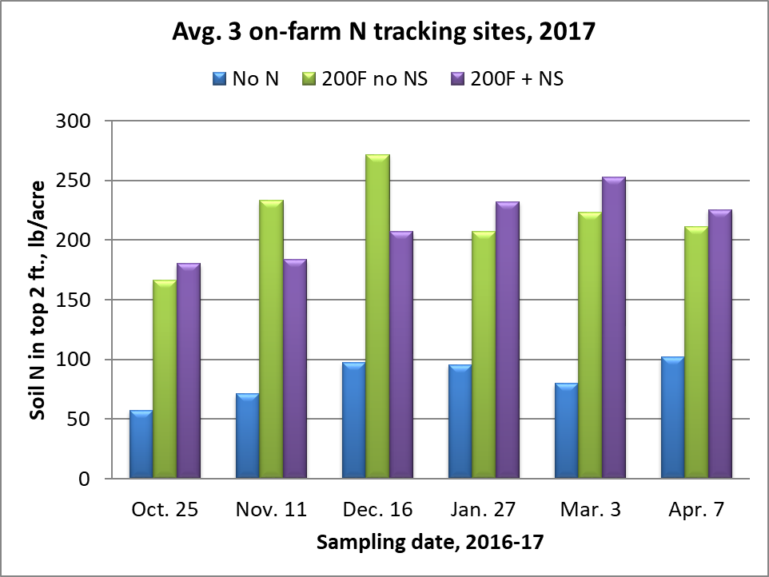

Figure 7. Soil N recovery over the fall and winter, 2016-17, averaged over three on-farm sites.

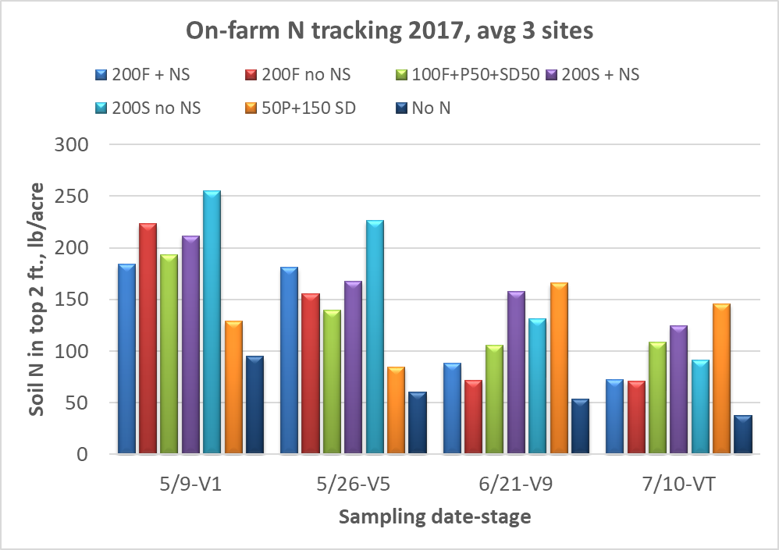

Figure 8. Soil N recovery in the spring of 2017, averaged over three on-farm sites.

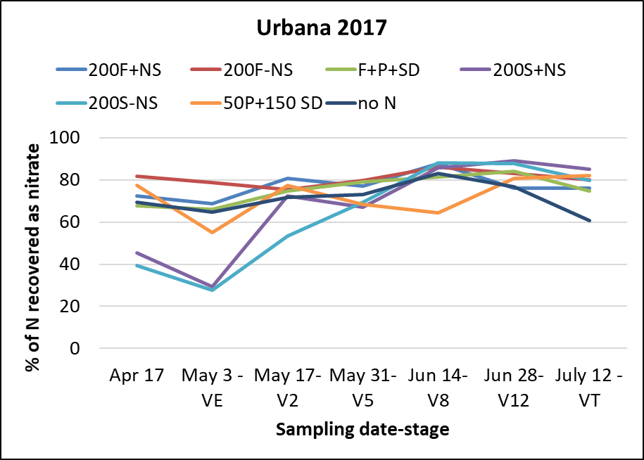

Figure 9. Percentage of soil N recovered as ammonium at Urbana, 2016.

Table 1. Corn yields with different N forms and timings in the N-tracking sites on RECS in 2017. Numbers followed by the same letters within a location aren’t significantly different at p=0.10. PT = planting time (UAN); SD = sidedress (UAN) at V5-V6.

|  |  |  |  |  |  |  |  |  |
| --- | --- | --- | --- | --- | --- | --- | --- | --- |
| Treatment | DeKalb | | Monmouth | | Urbana | | Perry | |
|  | ------------------------bushels per acre------------------------ | | | | | | | |
| Fall NH3 + N-Serve | 243 | b | 274 | a | 226 | abc | 171 | a |
| Fall NH3 no N-Serve | 256 | ab | 271 | a | 234 | ab | 178 | a |
| Fall 100 NH3+NS +PT50 +SD50 | 254 | ab | 280 | a | 221 | abc | 170 | a |
| Spring NH3 + N-Serve | 250 | ab | 275 | a | 238 | a | 165 | a |
| Spring NH3 no N-Serve | 249 | ab | 271 | a | 231 | abc | 170 | a |
| P50 UAN +Sidedress 150 UAN | 261 | a | 257 | b | 217 | bc | 172 | a |
| No N | 166 | c | 205 | c | 174 | c | 121 | b |

Table 2. Corn yields with different N forms and timings in the on-farm N-tracking sites in 2017. Numbers followed by the same letters within a location aren’t significantly different.

|  |  |  |  |  |  |  |  |  |
| --- | --- | --- | --- | --- | --- | --- | --- | --- |
| Treatment | Ford Co. | | McLean Co. | | Christian Co. | | Avg. 3 sites | |
|  | ------------------------bushels per acre----------------------- | | | | | | | |
| Fall NH3 + N-Serve | 262 | ab | 274 | a | 277 | a | 271 | ab |
| Fall NH3 no N-Serve | 242 | b | 267 | a | 247 | cd | 252 | c |
| Fall 100 NH3+NS + PT50+ SD50 | 250 | b | 268 | a | 258 | bcd | 259 | bc |
| Spring NH3 + N-Serve | 284 | a | 271 | a | 270 | ab | 275 | a |
| Spring NH3 no N-Serve | 260 | b | 280 | a | 263 | abc | 267 | ab |
| PT50 UAN +Sidedress 150 UAN | 254 | b | 285 | a | 241 | d | 260 | abc |
| No N | 136 | d | 175 | b | 164 | e | 158 | d |

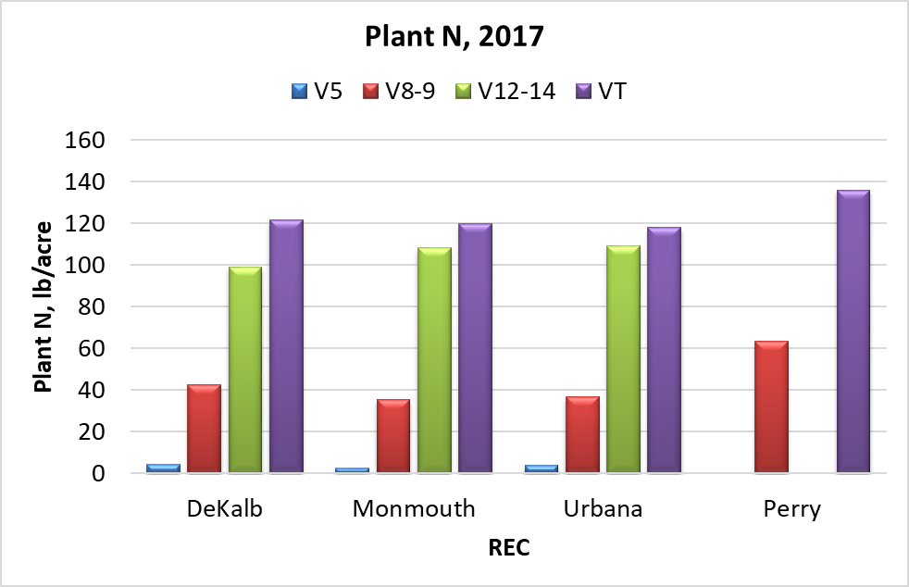

Figure 10. Plant N content by site at different sampling times in 2017. Plants were sampled only twice at Perry.